Nepal College of Information Technology
Unit Test
Fall 2013
Program : BE_IT_Day Time : 2 hrs
Semester : (VII) FM : 70
Subject : Engineering Mathematics-I PM : 35

- Candidates are requested to give their answer as far as practicable in their own words.
- The figure in the margin indicates the full marks
- Attempt ALL question

1. a) If a function f (x) is derivable at a point x = c. Show that f(x) is continuous at x = c. By taking suitable example show that the converse may not be true. (7)
b) State Leibnitz theorem for successive derivative of the product of two functions. If y = tan⁻¹x, show that (8)
i) (1 + x²)y₁ = 1
ii) (1 + x²)y_{n+1} + 2nxy_{n} + n(n-1)y_{n-1} = 0
2. a) State and prove Lagrange’s mean value theorem. Use it to show that if f'(x) > 0 in [a, b] function f(x) is increasing in [a, b]. (8)
b) State L. Hospital’s theorem. Evaluate 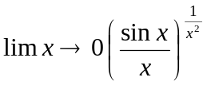 (7)
3. a) Show that the area of astroid 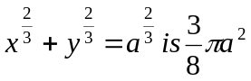. (7)

b) Show that the semi-vertical angle of the cone of maximum volume of a given slant height is tan⁻¹(). (8)

4. a) Find the reduction formula for 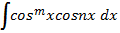 and then evaluate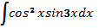. (8)
b) Define gamma function and prove that: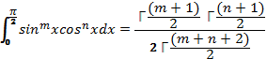 (7)
5. Evaluate ( any two) (2*5=10)
a) 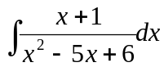
b) 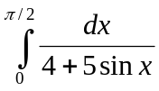
c) 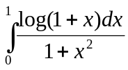
d) 